**16-BIT SUBTRACTION**  
**EXP NO: 6**  
**AIM:**To write an assembly language program to implement 16-bit subtraction using 8085 processor.  
**ALGORITHM:**  
1)   Start the program by loading a register pair with address of 1st number.  
2)   Copy the data to another register pair.  
3)    Load the second number to first register pair.  
4)    Subtract the two register pair contents.  
5)    Store the value of difference and borrow in memory locations.  
6)      End.  
  
**PROGRAM:**  
      LHLD 2050  
      XCHG  
      LHLD 2052  
      MVI C,00  
      MOV A, E  
      SUB L  
      STA 2054  
      MOV A, D  
      SUB H  
      STA 2055  
      HLT  
  
**INPUT & OUTPUT**

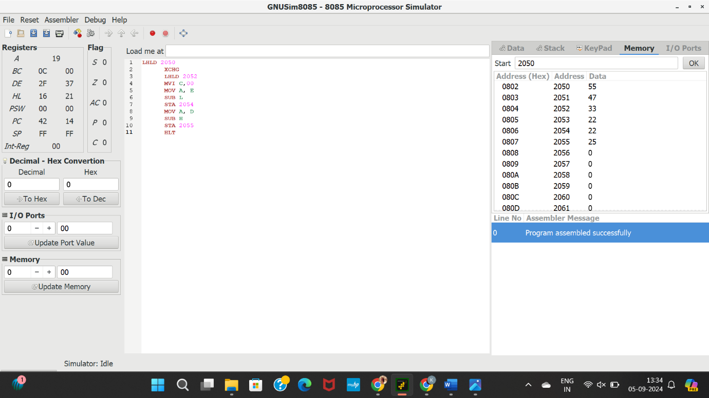

**RESULT:**Thus the program was executed successfully using 8085 processor simulator.